Ideation Phase
Empathize & Discover
Date | 8 March 2026
Team ID | AVK103
Project Name | Avi-Luxe E-commerce Application
Maximum Marks | 4 Marks

Empathy Map Canvas
An empathy map is a simple, easy-to-digest visual that captures knowledge about a user's behaviours and attitudes. It is a useful tool that helps teams better understand their users.
Creating an effective solution requires understanding the true problem and the person who is experiencing it. The exercise of creating the map helps participants consider things from the user's perspective along with his or her goals and challenges.
Reference: https://www.mural.co/templates/empathy-map-canvas

Empathy Map Framework — Six Components
Each empathy map is structured around six core sections:
• THINK & FEEL — What really counts to the user: their major preoccupations, worries, and aspirations
• HEAR — What the user hears from friends, colleagues, managers, and influencers
• SEE — What the user observes in their environment: what the market offers, what competitors look like, what friends do
• SAY & DO — The user's attitude and behaviour in public: what they say out loud and what they actually do
• PAIN — The user's fears, frustrations, and obstacles that prevent them from achieving their goals
• GAIN — What the user wants and needs: their measures of success and desired outcomes

Personas Overview — Three Empathy Maps
Three empathy maps have been created for the Avi-Luxe application, representing the three primary user types identified from the codebase, user research, and product gap analysis:

Map | Persona | Role | Key Goal | Primary Pain | Primary Gain
EM-1 | Priya — Fashion Shopper  (Age 28, Mumbai) | Primary Customer  Shops 3–4x/month | Discover and purchase premium fashion online with a luxury feel | No wishlist; COD-only checkout; no Google login | Immersive 3D hero, dark luxury theme, fast search, discount badges
EM-2 | Raj — Store Administrator  (Age 35, Operations Mgr) | Admin Persona  Manages catalogue daily | Manage products, orders, and revenue in one visual interface | No Admin Dashboard UI; all changes require API calls via Postman | Visual admin panel, one-click product CRUD, revenue chart (Sprint 2)
EM-3 | Arjun — Returning Customer  (Age 32, Regular buyer) | Secondary Customer  2–3 orders/month | Track order status in real time and receive proactive updates | No email/push notifications; checks app 3–4x/day with no update | Email at each order stage, order history detail, fast re-order (Sprint 2)

Empathy Map 1 — Priya: Primary Fashion Shopper
Priya is a 28-year-old marketing professional based in Mumbai. She is the primary customer persona for Avi-Luxe — a fashion-conscious urban professional who shops online 3–4 times per month, has disposable income, and expects a genuinely premium experience. She is the user most directly impacted by the quality of the product catalog, cart, and checkout experience.

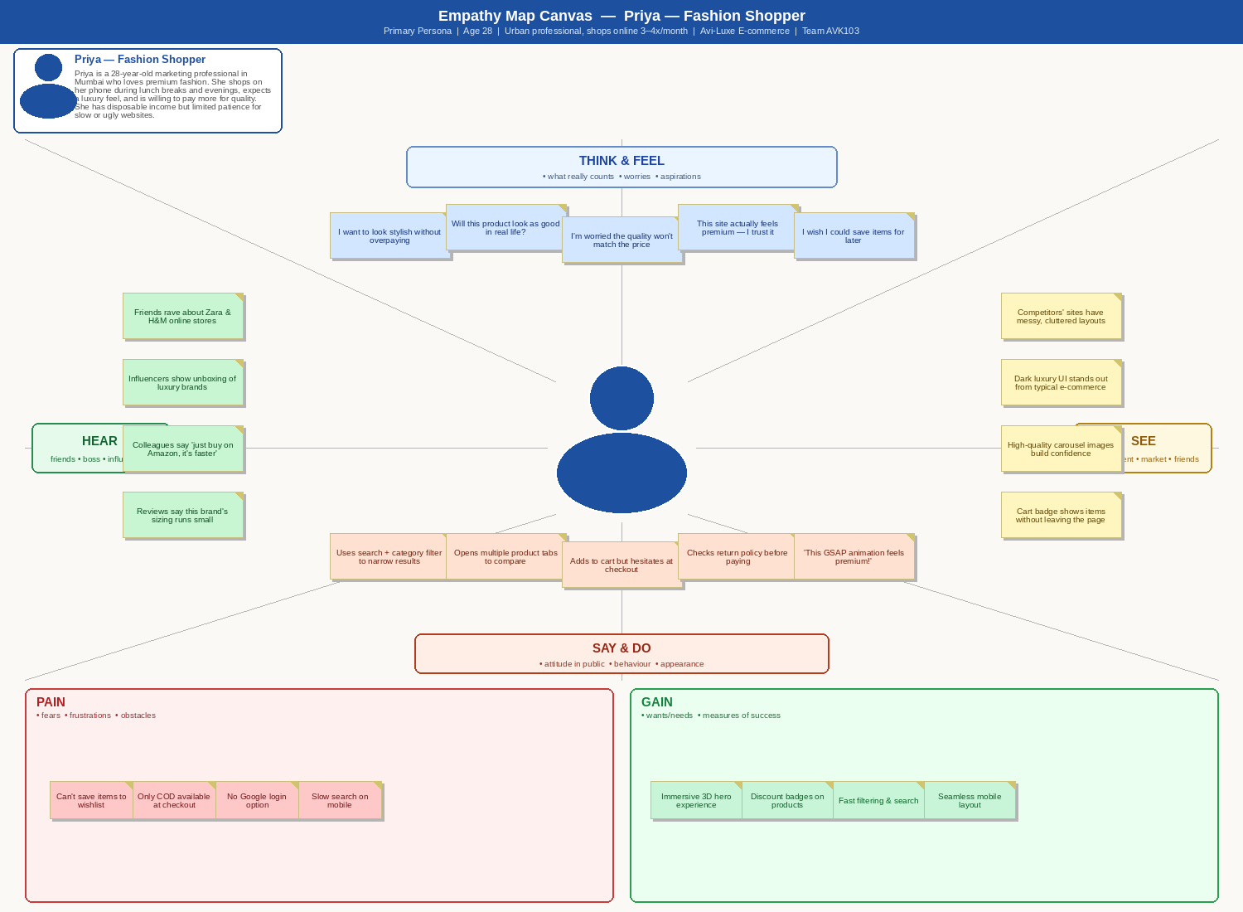

Detailed Empathy Insights — Priya
Section | Insights
THINK & FEEL  What really counts, worries, aspirations | • I want to look stylish and express my personality without overpaying  • Will this product look as good in real life as it does in the photo?  • I'm worried the quality won't match the premium price point  • This site actually feels luxurious — I trust it more than typical e-commerce  • I really wish I could save items to a wishlist and come back later
HEAR  Friends, influencers, social media, colleagues | • Friends rave about Zara and H&M's online experience: 'the filters actually work'  • Fashion influencers on Instagram show luxury unboxing hauls that set expectations  • Colleagues say 'just buy it on Amazon — it's faster and cheaper'  • Product reviews mention brand sizing runs small — she adjusts her size selection
SEE  Environment, what the market offers, friends | • Competitors' websites feel messy, cluttered, and untrustworthy for luxury items  • Avi-Luxe's dark luxury UI immediately stands out from generic e-commerce  • High-quality carousel images with multiple angles build purchase confidence  • Cart badge in the navbar shows item count without requiring a page change
SAY & DO  Attitude in public, behaviour, appearance | • Uses the search bar and category/gender filters to narrow down results quickly  • Opens multiple product detail tabs to compare styles, brands, and prices  • Adds items to cart but often hesitates at checkout due to COD-only payment  • Checks the return policy before committing to any purchase  • Openly shares: 'This GSAP animation feels genuinely premium!'
PAIN  Fears, frustrations, obstacles | • Cannot save products to a wishlist — must re-search every time she returns  • Only Cash-on-Delivery available at checkout; no card/UPI/netbanking option  • No Google OAuth — must create a new password for yet another platform  • Search feels slow on mobile; filter interactions are difficult on small screens
GAIN  Wants, needs, measures of success | • An immersive Three.js 3D hero and GSAP animations that communicate luxury  • Discount percentage badges prominently displayed on product cards  • Fast, server-side filtered search with 350ms debounce for instant results  • Fully mobile-responsive layout that works flawlessly on her iPhone

Design Implications — Priya
• GSAP animations and the Three.js 3D hero scene directly address her expectation of a premium, differentiated UI
• Server-side product filtering with 350ms debounce solves her mobile search frustration
• Wishlist feature (planned Sprint 2) will prevent cart abandonment when she is not ready to buy
• Razorpay/Stripe integration (Sprint 3) will resolve the checkout drop-off caused by COD-only payment
• Google OAuth (Sprint 2) will reduce registration friction and increase sign-up conversion

Empathy Map 2 — Raj: Store Administrator
Raj is a 35-year-old e-commerce Operations Manager responsible for managing the Avi-Luxe product catalogue, order fulfilment, and user accounts on a daily basis. He is technically comfortable but not a developer. He represents the Administrator persona — a critical internal user whose efficiency directly affects the business's ability to operate.

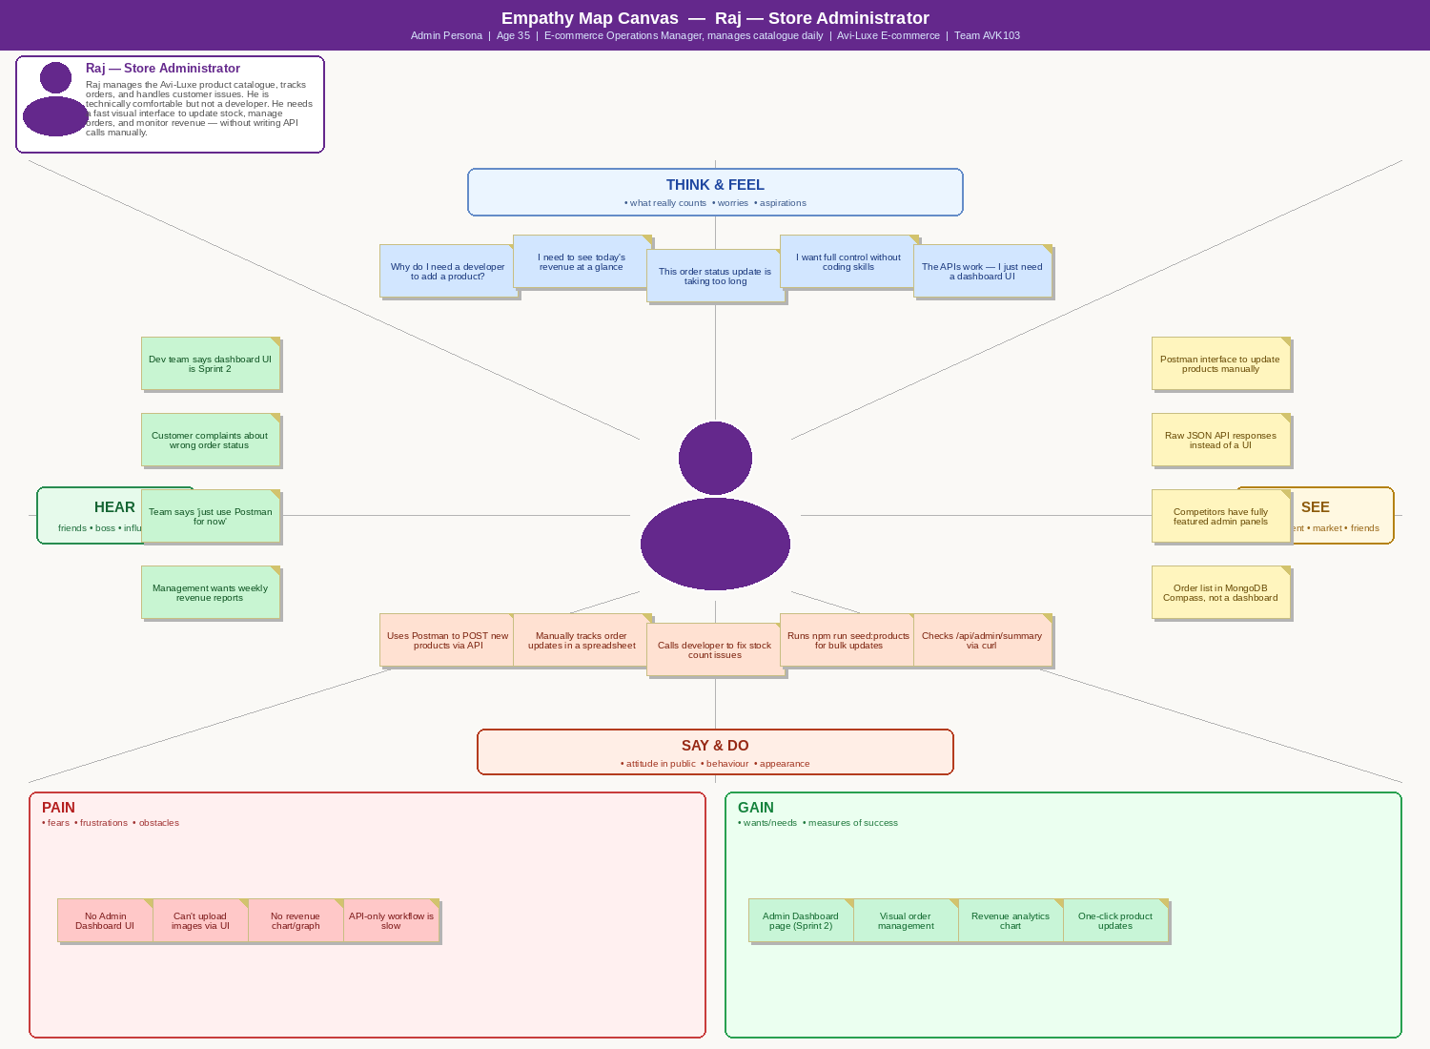

Detailed Empathy Insights — Raj
Section | Insights
THINK & FEEL  What really counts, worries, aspirations | • Why do I need to ask a developer every time I want to add a new product?  • I need to see today's revenue and order count at a glance on a dashboard  • Updating order status via Postman API calls is embarrassing and inefficient  • I want full control over the catalogue without needing to write any code  • The server APIs all work perfectly — the admin UI frontend is the only missing piece
HEAR  Dev team, management, customers | • Dev team says: 'Admin Dashboard UI is planned for Sprint 2 — APIs are ready'  • Customer complaints about incorrect order status come through email directly to Raj  • Team says: 'Just use Postman for now — it's only temporary'  • Management wants weekly revenue reports but the data is buried in MongoDB
SEE  Tools, competitor platforms, workarounds | • Uses Postman to manually make POST requests when adding or updating products  • Raw JSON API responses instead of a human-readable admin dashboard  • Competitors (Shopify, WooCommerce) have fully featured, polished admin panels  • Tracks order status updates in a personal spreadsheet as a workaround
SAY & DO  Attitude in public, behaviour, appearance | • Runs POST /api/products manually via Postman to add each new product  • Maintains a separate spreadsheet to track order status and customer details  • Calls the developer when stock counts or product data need updating  • Runs 'npm run seed:products' for bulk product inserts — not sustainable long-term  • Checks GET /api/admin/summary via curl to get revenue figures
PAIN  Fears, frustrations, obstacles | • No Admin Dashboard UI — the most critical missing frontend feature  • Cannot upload product images through a UI; must provide external URLs manually  • No revenue chart or visual analytics — data hidden in raw API responses  • API-only workflow is time-consuming and risks errors from manual JSON entry
GAIN  Wants, needs, measures of success | • A visual Admin Dashboard page with product table, order management, and revenue chart  • One-click product creation, editing, and soft-delete via a form UI  • Real-time revenue summary and order count cards at the top of the dashboard  • User management panel to view, enable/disable, or promote customer accounts

Design Implications — Raj
• Admin Dashboard UI (planned Sprint 2) is the single most impactful feature for Raj — all server APIs are already functional
• Visual product form (create/edit/delete) will replace Postman-based API calls for catalogue management
• Revenue summary cards using GET /api/admin/summary will give Raj the at-a-glance reporting he needs
• Order management table with inline status update will eliminate the spreadsheet workaround
• User management panel will allow Raj to enable, disable, and promote accounts without developer involvement

Empathy Map 3 — Arjun: Returning Customer (Order Tracker)
Arjun is a 32-year-old loyal Avi-Luxe customer who places 2–3 orders per month. He is the secondary customer persona — a repeat buyer who values transparency, communication, and trust. His primary frustration is the complete absence of post-purchase communication: no email confirmations, no shipping notifications, and no delivery alerts.

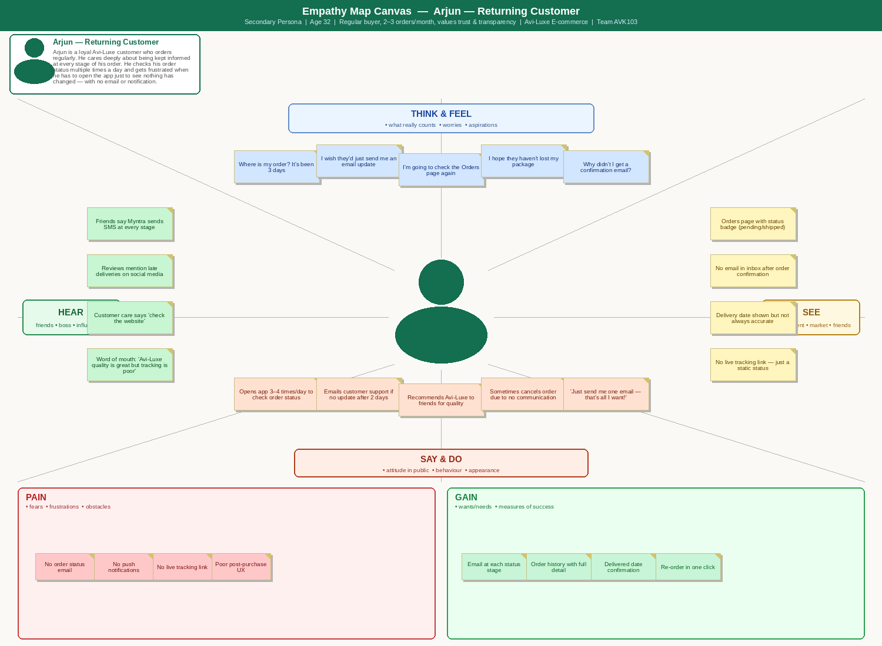

Detailed Empathy Insights — Arjun
Section | Insights
THINK & FEEL  What really counts, worries, aspirations | • Where is my order? It's been 3 days since I placed it and there's been no update  • I'm worried my package has been lost or forgotten in the fulfilment process  • I shouldn't have to open the app 4 times a day to find out the same status  • I hope the delivery date shown on the Orders page is actually accurate  • Why didn't I receive a single email confirmation after placing my order?
HEAR  Customer care, friends, word of mouth | • Friends say: 'Myntra sends an SMS at every single delivery stage — why can't Avi-Luxe?'  • Social media reviews mention late deliveries and lack of communication  • Customer care responds to status queries with: 'Please check the website'  • Word of mouth: 'Avi-Luxe has great quality but terrible post-purchase communication'
SEE  Orders page, email inbox, competitor apps | • Orders page shows a status badge (Pending / Shipped) but no detailed timeline  • Email inbox is empty — no order confirmation, no shipping notification received  • Delivery date is displayed on the order but is not always updated accurately  • Competitor apps show live courier tracking links with real-time map view
SAY & DO  Attitude in public, behaviour, appearance | • Opens the Avi-Luxe app 3–4 times per day just to check if the status has changed  • Sends a customer support email if there is no update after 2 business days  • Actively recommends Avi-Luxe to friends for product quality despite this frustration  • Has cancelled an order after extended silence — even though the order was en route  • Tells friends: 'Just one email — that's literally all I want from them!'
PAIN  Fears, frustrations, obstacles | • No order status confirmation or shipping notification email is ever sent  • No push notification system — must manually check the app for updates  • No courier tracking link embedded in the Orders page  • Poor post-purchase experience undermines trust in an otherwise excellent product
GAIN  Wants, needs, measures of success | • Automated email notification at each order status change (confirmed, shipped, delivered)  • Full order history with item details, prices, delivery date, and status timeline  • Delivered date confirmation email with a prompt to leave a product review  • One-click re-order button for frequently purchased items

Design Implications — Arjun
• Email integration (Nodemailer + SendGrid, planned Sprint 2) is the highest priority fix for Arjun's experience
• Order status emails at each of the 5 pipeline stages (pending → confirmed → shipped → delivered → cancelled) will eliminate his anxiety
• The Orders page already shows status badges and delivery dates — adding a status timeline component would further improve clarity
• A re-order button on completed orders would reduce friction for his 2–3 monthly repeat purchases
• Product review prompt in the delivery confirmation email would leverage his loyalty to build social proof on the platform

Summary — Key Insights Across All Personas
The three empathy maps reveal a consistent pattern of product strengths and gaps across all Avi-Luxe user types:

Theme | Current Strength (Sprint 1 ✓) | Gap / Planned Fix (Sprint 2–3)
Visual Experience | GSAP animations, Three.js 3D hero, dark luxury theme, carousel images | Wishlist page with saved product tiles
Discovery & Search | Regex search, category/gender/price filters, 350ms debounce | Enhanced mobile filter UX, price range slider
Cart & Checkout | MongoDB-persisted cart, server-side pricing, order confirmation toast | Razorpay/Stripe payment integration (Sprint 3)
Post-Purchase | Order status pipeline (5 states), delivery date, order history page | Email notifications at each stage via Nodemailer (Sprint 2)
Admin Operations | Full CRUD APIs for products, orders, users, settings (server-side) | Admin Dashboard UI with revenue chart, product form, order table (Sprint 2)
Auth & Onboarding | JWT auth, bcryptjs hashing, ProtectedRoute, isActive guard | Google OAuth / Facebook Login via Passport.js (Sprint 2)

References
• MURAL Empathy Map Canvas Template: https://www.mural.co/templates/empathy-map-canvas
• Nielsen Norman Group — Empathy Mapping Guide: https://www.nngroup.com/articles/empathy-mapping/
• Project Repository: https://github.com/AVK103/Avi-Luxe__E-commerce-Application

